Dennys Urdiales

10/10/2023

Deep Learning

Charity Funding Predictor

Overview

The goal of this project is to create an algorithm using machine learning and neural networks that can predict if applicants will be successful if they were funded by Alphabet Soup.

Data Preprocessing

The data was preprocessed by:

* Dropping the non-beneficial ID columns.
* Finding the number of unique values in each column and choosing the columns with more than 10 bins: Application_Type & Classification.
* Setting the Application Type cutoff value to 600 and the Classification cut off value to 670.
* Checking to see if binning was successful.
* Converting categorical data to numeric data using get_dummies.
* Splitting preprocessed data into features and target arrays (IS_SUCCESSFUL) and putting it into a training and testing dataset.
* Using the standardScaler to train the data set.

The target variable was (y) was “IS_SUCCUSSFUL” and the data was split into training and testing subsets.

Compiling, Training, and Evaluating the Model

The model required to achieve an accuracy score higher than 75%. Three attempts were made to achieve this but were not successful. The acquired accuracy scores I obtained were around 73%.

Attempt #1

The first attempt resulted an accuracy score of 73.04% meaning that 73.04% of the model’s prediction were true values.

The hyperparameters used were:

* Layers: 2
  + Layer 1: 50 neurons and ‘relu’ activation function
  + Layer 2: 80 neurons and ‘relu’ activation function
* Epochs:100

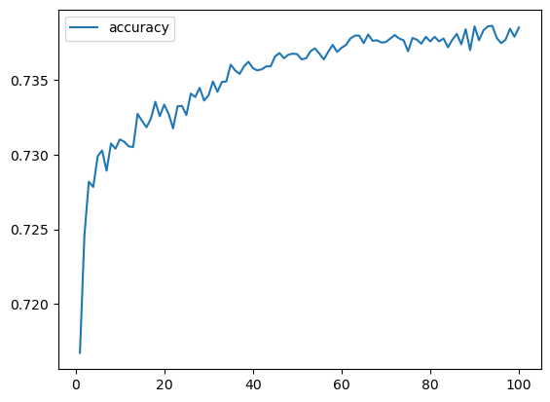

Attempt #2

The first attempt resulted an accuracy score of 73.67% meaning that 73.67% of the model’s prediction were true values.

The hyperparameters used were:

* Layers: 2
  + Layer 1: 500 neurons and ‘relu’ activation function
  + Layer 2: 800 neurons and ‘relu’ activation function
* Epochs:180

Attempt #3

The first attempt resulted an accuracy score of 73.65% meaning that 73.65% of the model’s prediction were true values.

The hyperparameters used were:

* Layers: 2
  + Layer 1: 909 neurons and ‘relu’ activation function
  + Layer 2: 398 neurons and ‘relu’ activation function
* Epochs:100

Summary

In the three attempts made, the model was not able to achieve the targeted accuracy of 75% with the highest obtained accuracy being 73.67%. Hypertuning was not helpful for this model, I would consider another model to try this again.